**Isohyetal analysis of a flood event over Lower Chambal River sub-basin to compute Average Area Precipitation (AAP) using raster interpolation technique.**

**Abstract:**

The isohyetal method is used to estimate the mean precipitation across an area by drawing lines of equal precipitation. In the isohyetal method, precipitation values are plotted at the respective stations on a suitable base map, and isohyets are drawn to create an isohyetal map. Isohyetal lines are based on interpolation between rain gauge stations and are contours of equal precipitation analogous to contour lines on a topographic map. While constructing isohyets, it is assumed that rainfall between two stations varies linearly, unless abrupt change in topography indicated otherwise (Jain & Singh, 2005). After listing the input data from the Lower Chambal River sub-basin, identifying all the geoprocessing tools needed to perform isohyetal analysis in ArcGIS (Law & Collins, 2015) and describing the desired outputs, we used Model Builder which is a visual programming language to automate the geoprocessing workflow. The model is represented as a diagram that chains together sequences of processes and geoprocessing tools, using the output of one process as the input to another process. This marks as a first automation of the process of isohyetal analysis for the Hydrology section of India Meteorological Department (IMD), Delhi. The use of this model relieves the hydrologist of the tedious job of drawing a map, interpolating precipitation from point data, and drawing isohyets. Although largely accurate, the isohyetal maps should be refined later by the hydrologist using additional information, experience, and judgement. This combination provides better results and considerable saving of time.

**Introduction:**

An accurate assessment of the mean areal precipitation is needed in many hydrologic analyses. Precipitation observations from gauges are point measurements, and precipitation exhibits appreciable spatial variation over relatively short distances. Numerous methods of computing areal precipitation from point measurements have been proposed, such as the arithmetic average method, the Thiessen polygon method, the Isohyetal method, and kriging. The method uses topographic and other data to yield reliable estimates. The choice of any method depends on the quality and nature of data, precision required (Singh, 1989), the availability of time and resources, and the preference of the analyst.

Let the precipitation data be available at n stations, spread over an area and Pi be the observed depth of the precipitation at the station. Using a linear interpolation technique, an estimate of the precipitation across the area can be expressed by

where is the weight at the station. Spatial averaging techniques differ in the method of evaluating these weights. The weights of an optimal interpolation technique are chosen so that the variance of error in estimation is a minimum.

The simplest technique for computing the average precipitation depth across a catchment is to take an arithmetic average of the observed depth at gauges within the area for the time of concern. This technique yields satisfactory results when the gauges are uniformly distributed across the catchment and the precipitation depth does not vary greatly but it is rarely the case. For these reasons, a technique like isohyetal method is needed that considers the spatial variability of precipitation. Here, the areas enclosed by two successive isohyets are multiplied by the average of the isohyets to obtain the volume of the precipitation needed to compute the average rainfall depth across the basin. However, a more accurate value of mean areal rainfall is obtained if the length of the isohyets are measured as well as the area between the isohyets. If ‘b’ is the length of the lower value isohyet B, ‘a’ the length of the higher value isohyet A, and is the isohyet interval (A-B), then it can be shown that mean rainfall r for the segment is

**Data and Method:**

The data needed for this report was taken from Hydrology section, India Meteorological Department (IMD), Delhi; Central Water Commission (CWC), Chambal Division, Jaipur; Meteorological Centre, IMD, Jaipur; Meteorological Centre, IMD, Bhopal. The data includes shape file the Lower Chambal sub-basin and the rainfall records for the flood event of 14th - 19th August 2019.

The methodology includes two parts: 1) Isohyetal Analysis in ArcGIS. 2) Model building.

Steps of the Isohyetal Analysis in ArcGIS:

* We filter and plot the different rain-gauge stations in the objective area along with the rainfall value using spatial join analysis tool from the GIS (Geographical Information System) toolkit.
* We proceed with raster interpolation using Topo to Rater tool which uses the knowledge of surfaces, interpolates a hydrologically correct raster surface from point elevations that were provided. It creates a hydrologically correct DEM (Digital Elevation Model) by interpolating elevation values for a raster albeit using constraints that ensure a connected drainage structure and a correct representation of ridges and streams from input contour data.
* Isohyets are drawn using the contour list tool after the maximum and minimum contours are decided by the visual inspection of the input data.
* Contours are clipped to the Lower Chambal area and the outer boundary of the shape file is included using the Feature to Polygon tool.
* This is followed by joining the data of the two layers (The feature to polygon layer and the layer containing the clipped contours) based on their spatial locations. This includes finding the area between the Isohyets and information of the corresponding minimum and maximum contours enclosing each area.
* We input the projected output coordinate system: WGS-1984-UTM-43N using the project tool from the project and transformation toolbox.
* Using the conversion toolbox, we export the projected table containing all the necessary inputs to excel.
* Then, we calculate the Average Area Precipitation (AAP) using the mean precipitation equation explained in the previous section.

Steps for model building:

We know, geoprocessing models automate and document our spatial analysis and data management processes. We create and modify geoprocessing models in Model Builder, where a model is represented as a diagram that chains together sequences of processes and geoprocessing tools, using the output of one process as the input to another process. Following the steps above, our model runs the following tools in sequence:

* Make XY Event: It creates a new point feature layer based on x- and y-coordinates defined in a table. If the source table contains z-coordinates (rainfall elevation values in our case), that field can also be specified in the creation of the event layer.
* Copy Features: It copies features from the input feature class or layer to a new feature class.
* Topo to Raster: It is an interpolation method specifically designed for the creation of hydrologically correct digital elevation models (DEMs).
* Contour list: It creates a feature class of selected contour values from a raster surface.
* Clip: It extracts input features that overlay the clip features.
* Feature to polygon: It creates a feature class containing polygons generated from areas enclosed by input line or polygon features.
* Spatial join: It joins attributes from one feature to another based on the spatial relationship.
* Project: Projects spatial data from one coordinate system to another.
* Table to excel: Converts a table to a Microsoft Excel file.

**Results and Discussion:**

1. Sub basin wise QPF (Quantitative Precipitation Forecast), Probabilistic QPF other relevant information is to be prepared by each Flood Meteorological Offices (FMOs) as per area of their jurisdiction for issuing QPF Bulletin and Hydrometeorological Bulletin during Flood Season. Quick computation of rainfall analysis will result in improved Quantitative Precipitation Forecasting for 3 days and outlook for next 4 days.

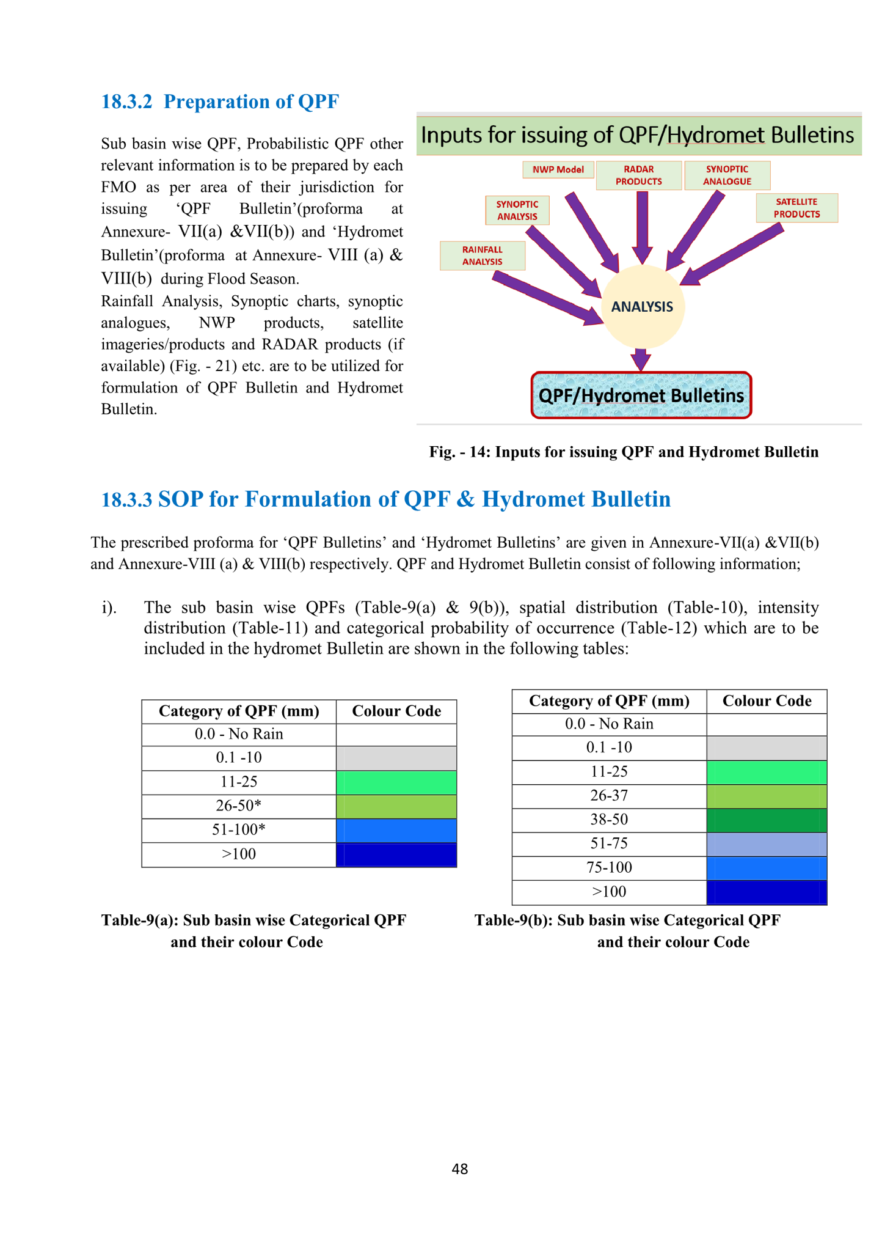

**Figure 1. Inputs for issuing Quantitative Precipitation Forecast (QPF) for river sub-basins by IMD**

1. A model has been devised for the automation of AAP calculation by isohyetal technique in Lower Chambal River sub-basin. The only inputs required are the file containing rainfall values of rain gauges in that sub-basin and contour list values, that depends on the range of rainfall values. The output of the model is the excel file with values of minimum and maximum contours along with corresponding enclosed area. AAP can be calculated using simple calculation on these values. This model can be altered for any other river sub-basin by just replacing the shape file of the river sub-basin. This automation has resulted in efficient resource utilisation by decreasing the time of computation exponentially, enhancing the accuracy of the result and reducing the human resource requirement. It's worth mentioning that the python script for the model is available in the output file for further use and edit.

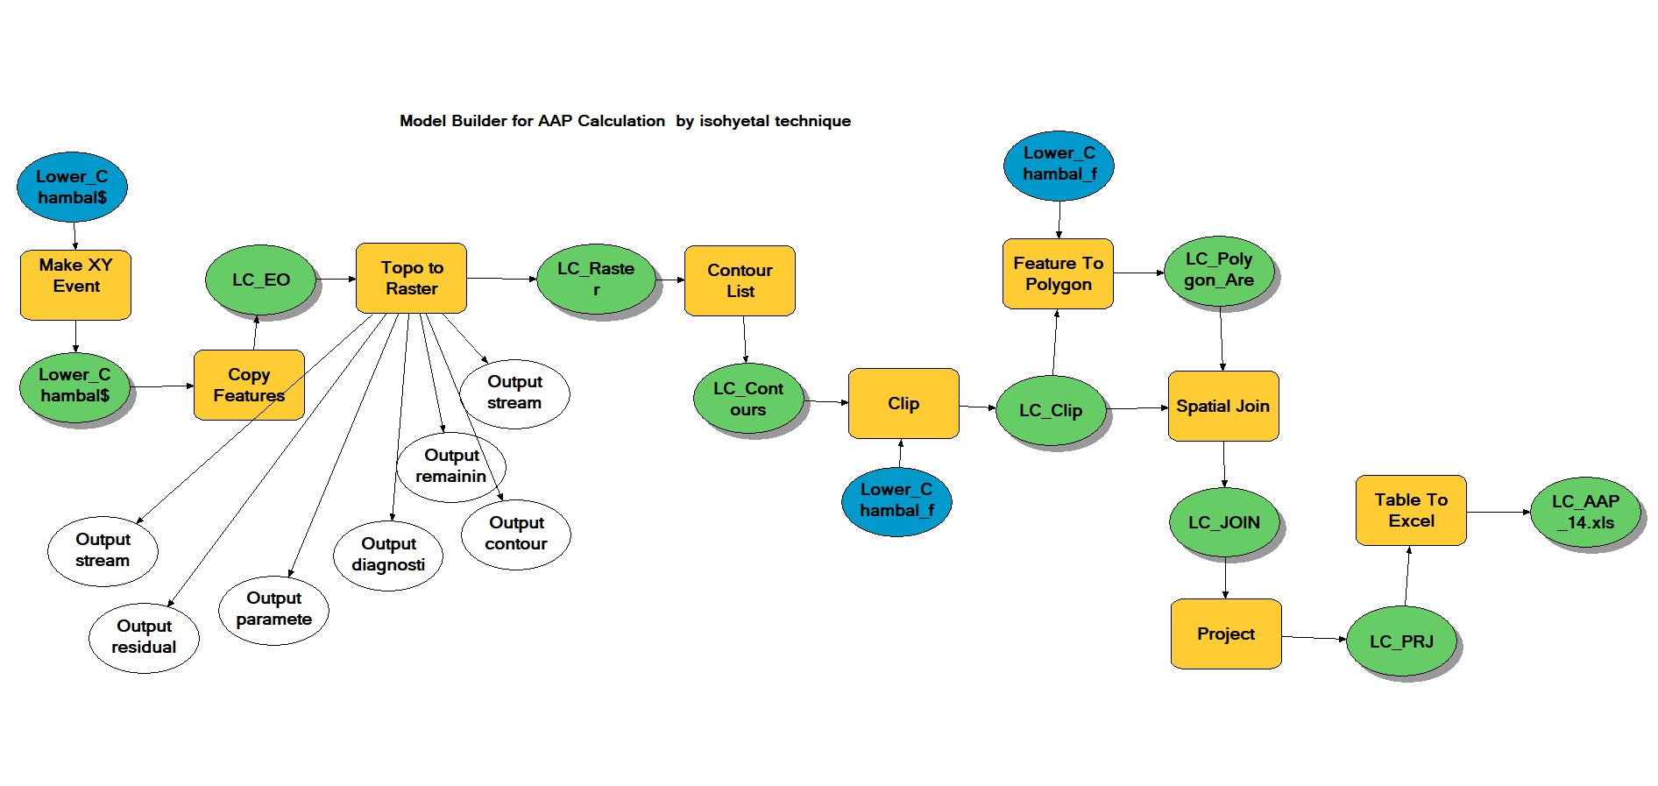

**Figure 2. Automated model for AAP calculation by Isohyetal technique**

1. This model has been deployed to compute the AAP and isohyetal maps of the flood event that occurred over Lower Chambal River sub-basin from 14th August to 19th August 2019. As Table 1. shows the AAP value kept on increasing from 23.22 mm on 14th August 2019 to 74.17 mm on 16th August,2019 with a decreasing trend thereafter. The synoptic situation on 16th August 2019 comprised of a well-marked low-pressure area persisting over northeast Rajasthan and adjoining areas of northwest Madhya Pradesh and southwest Uttar Pradesh, therefore, the region was likely to receive heavy to very heavy rains in the next 24 hours also. Thereafter, it moved gradually north-westwards along the monsoon trough. This resulted in flood like situations in Hadauti region of Rajasthan (It includes the districts of Bundi, Baran, Jhalawar and Kota), killing five people.

|  |  |
| --- | --- |
| **Dates** | **AAP value (mm)** |
| 14.08.2019 | 23.22 |
| 15.08.2019 | 63.34 |
| 16.08.2019 | 74.17 |
| 17.08.2019 | 23.29 |
| 18.08.2019 | 8.68 |
| 19.08.2019 | 9.44 |

**Table 1. Date wise AAP values computed by Isohyetal technique over Lower Chambal River sub-basin**

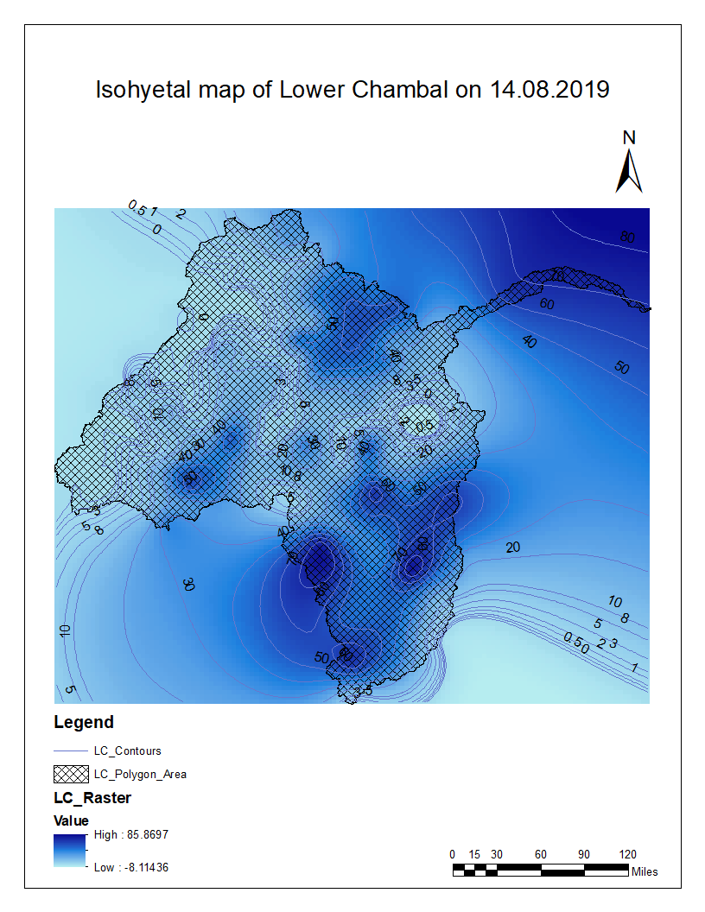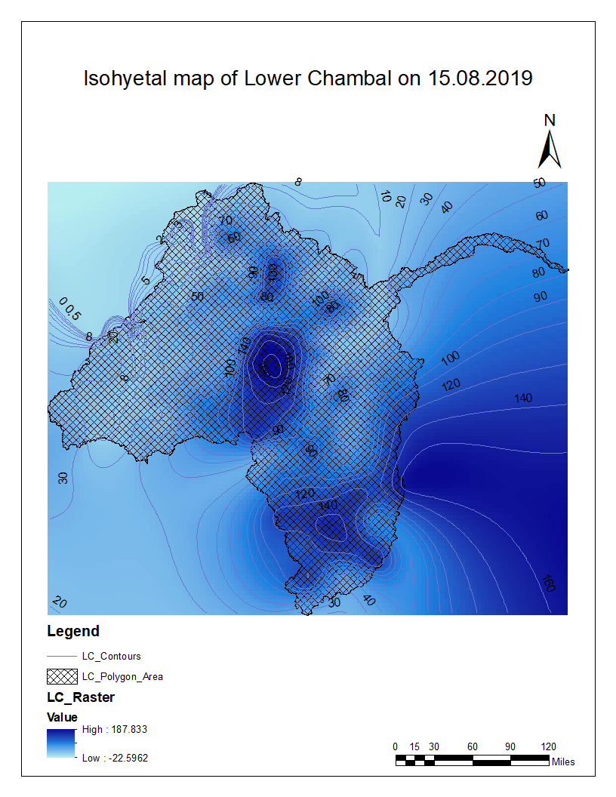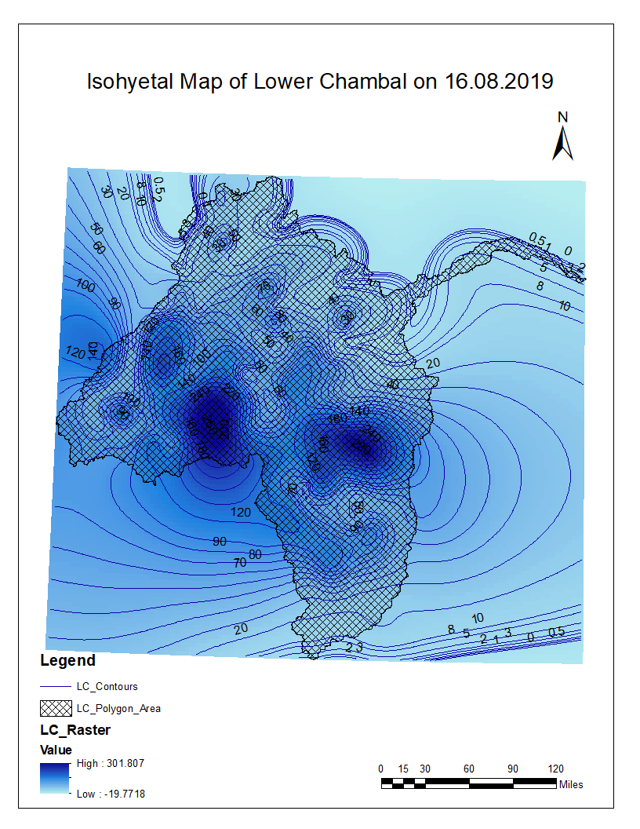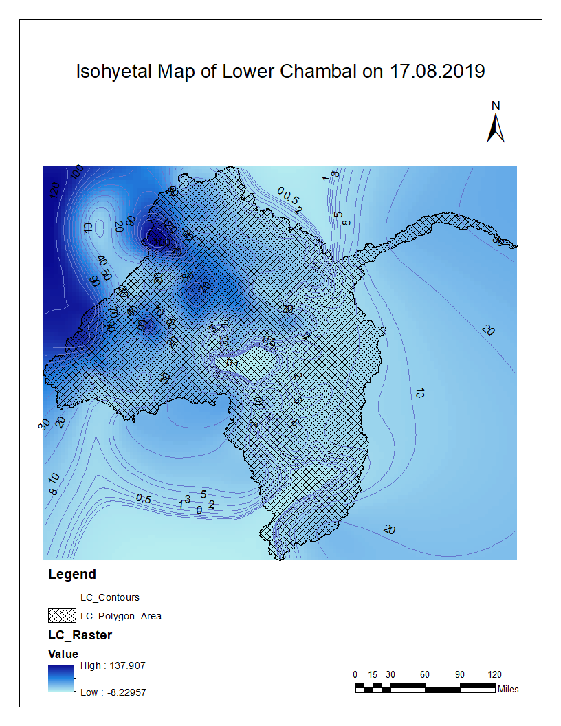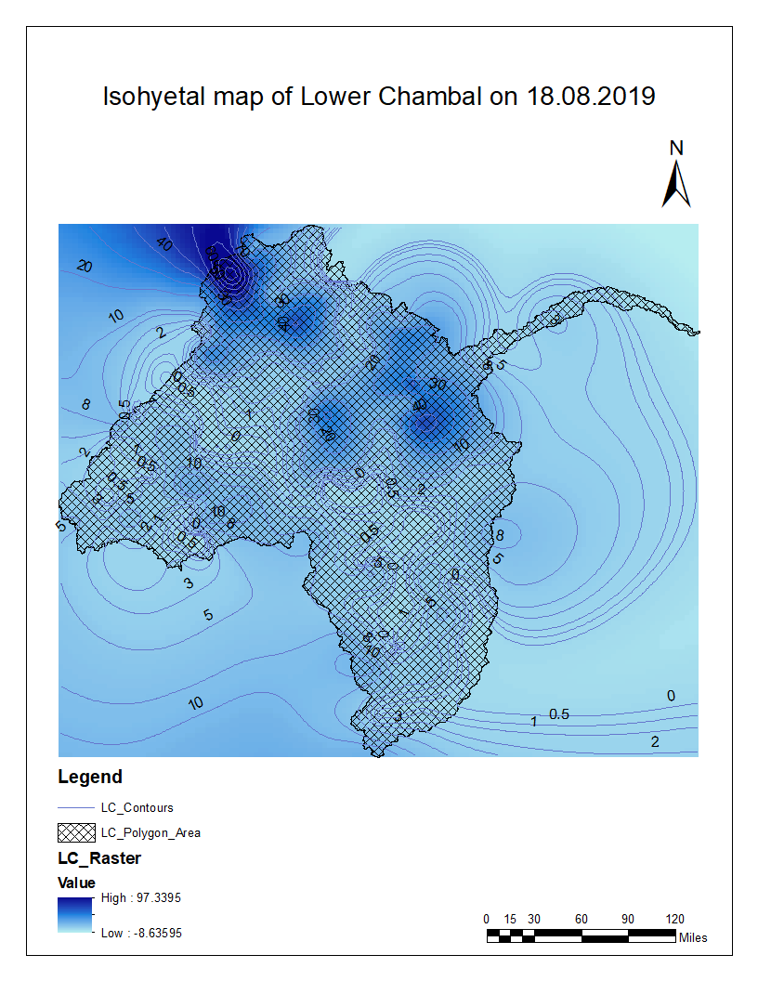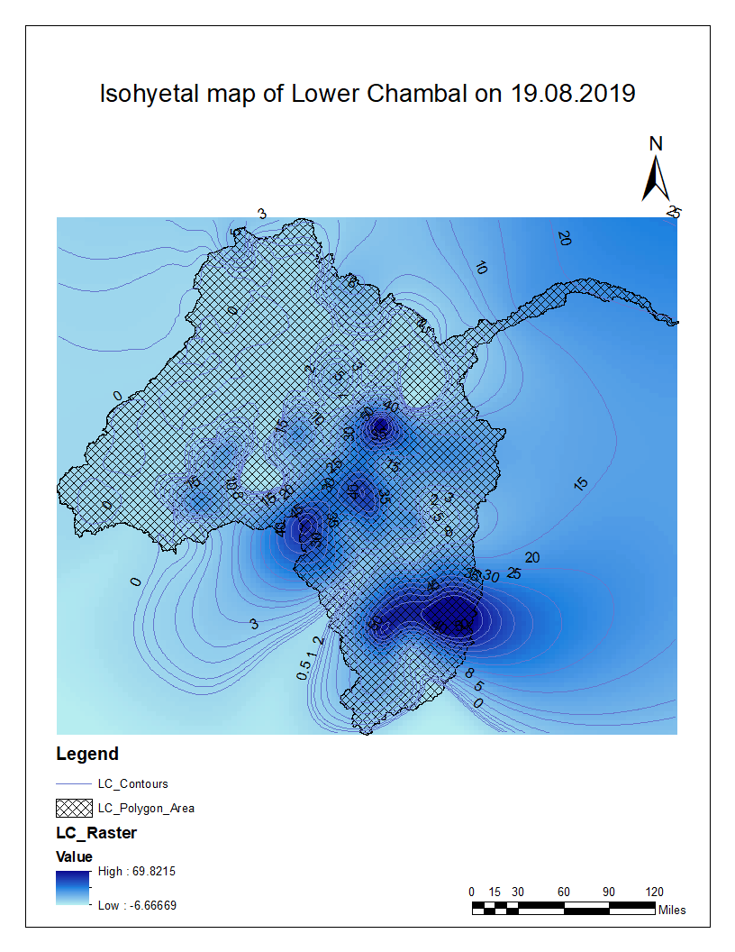

**Figure 3. Isohyetal maps with contours over Lower Chambal River sub-basin for the flood event (14th August – 19th August 2019)**

**Recommendations:**

1. This entire process of automated AAP calculation can be replicated in QGIS because it is a free and open-source cross-platform desktop geographic information system application. This will enable the implementation of this automated process across all 14 Flood Meteorological Offices (FMOs) of India Meteorological Department (IMD).

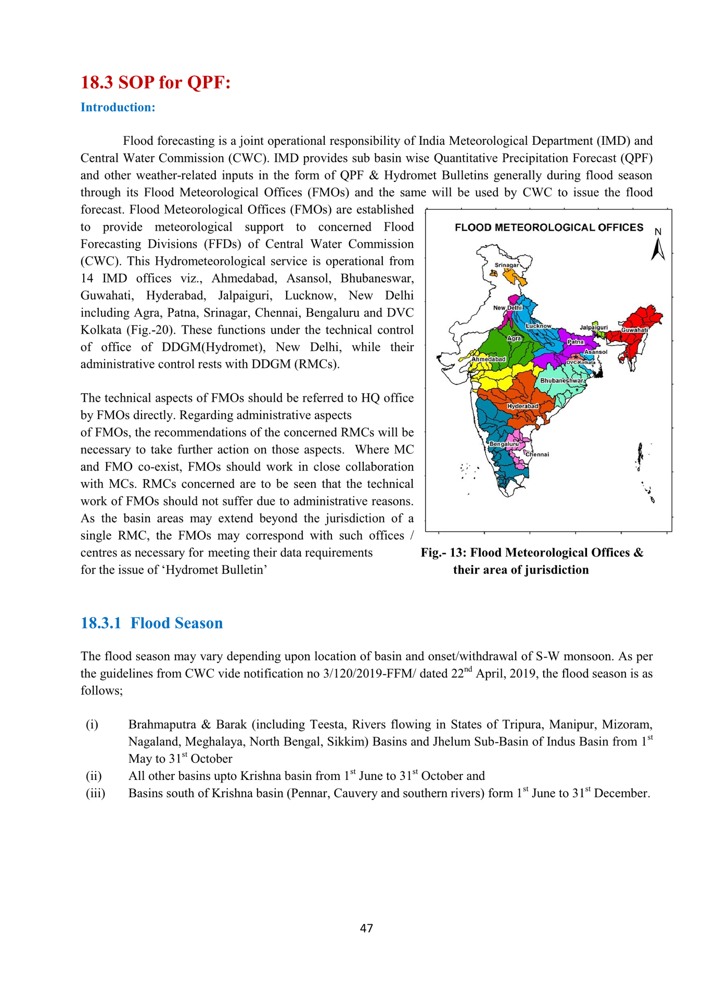

**Fig. Flood Meteorological Offices and their area of jurisdiction**

1. An alternative method can be devised to carry out isohyetal analysis for all the river sub-basins of India and thereafter AAP can be calculated by segregating different areas of sub-basins. This will result in more efficient resource utilisation.

**References:**

1. Jain, S. K., & Singh, V. P. (2005). Isohyetal Method. *Water Encyclopedia*, *4*, 290–292.
2. Law, M., & Collins, A. (2015). Getting to know ArcGIS. *Redlands: ESRI Press.*, 768.
3. Singh, V. P. (1989). Watershed Modeling. *Hydrologic Systems*, *Vol II*.
4. Indian Express, *Weather Forecast Today Highlights: Flood-like situation in Rajasthan’s Hadauti, 5 killed in rain-related incidents*, August 16, 2019
5. India Meteorological Department, *Standard Operating Procedure Hydrometeorological Services in India,* March, 2021